**GCSE**

**MATHEMATICS**

**10 for 10**

**Ten minutes a day for ten days**

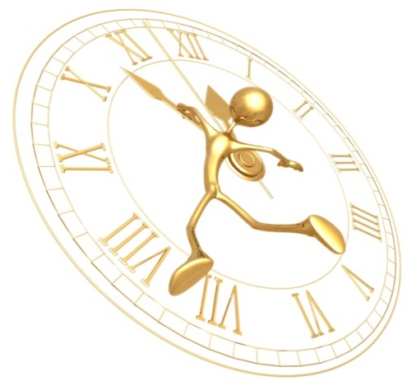

|  |  |
| --- | --- |
| **The Mathematics**  **Department** |  |

|  |  |  |
| --- | --- | --- |
| **10 for 10** | **Year 11 mathematics: holiday revision**  **Non-Calculator** | **DAY 1** |

**1.** One night at a school concert the audience is made up as follows:



(a) (i) What percentage of the audience are children?

.............................................................................................................

.............................................................................................................

(2)

(ii) What fraction of the audience are children?

.............................................................................................................

.............................................................................................................

.............................................................................................................

(3)

(b) The next night the audience is made up in the following ratio:



There are 270 people in the audience.  
Calculate the number of men.

........................................................................................................................

........................................................................................................................

........................................................................................................................

(2)

|  |  |  |
| --- | --- | --- |
| **10 for 10** | **Year 11 mathematics: holiday revision**  **Calculator** | **DAY 1** |

**2.** (a) Miss Evans earns £240 per week.  
She is awarded a pay rise of 3.5%.

Mr Dale earns £220 per week.  
He is awarded a pay rise of 4%.

Whose weekly pay increases by the greater amount of money?  
You **must** show all your working.

.............................................................................................................

.............................................................................................................

.............................................................................................................

.............................................................................................................

.............................................................................................................

.............................................................................................................

Answer ..................................................................

(4)

(b) In 2003 the State Pension was increased by 2% to £78.03.  
What was the State Pension before this increase?

.............................................................................................................

.............................................................................................................

.............................................................................................................

Answer £ .............................................................

(3)

|  |  |  |
| --- | --- | --- |
| **10 for 10** | **Year 11 mathematics: holiday revision**  **Non-Calculator** | **DAY 2** |

**3.** In the year 1900, estimates were made of the numbers of three types of whales.

The estimates were made again in 1993.

The information for the Sei Whales is not shown on the diagram.



(a)Find the following fraction, giving your answer in its simplest form.

1900

in

Whales

Blue

of

Number

1993

in

Whales

Blue

of

Number

........................................................................................................................

(1)

(b)Calculate the percentage decrease in the number of Fin Whales between the years 1900 and 1993.

........................................................................................................................

........................................................................................................................

(3)

(c)The ratio of Sei Whales for 1900 to Sei Whales for 1993 is 5 : 1.  
The combined total of these whales for the two years was 300 000.  
How many Sei Whales were estimated in 1900?

........................................................................................................................

(2)

|  |  |  |
| --- | --- | --- |
| **10 for 10** | **Year 11 mathematics: holiday revision**  **Calculator** | **DAY 2** |

**4.** James invests £700 for 2 years at 10% per year compound interest.  
How much interest does he earn?

..................................................................................................................................

..................................................................................................................................

..................................................................................................................................

..................................................................................................................................

Answer £ ....................................................................

(2)

|  |  |  |
| --- | --- | --- |
| **10 for 10** | **Year 11 mathematics: holiday revision**  **Non-Calculator** | **DAY 3** |

**5.** Yogurt is sold in small pots and large pots.

(a) A small pot costs 20 pence.  
A large pot costs 150% **more.**How much does a large pot cost?

........................................................................................................................

........................................................................................................................

........................................................................................................................

........................................................................................................................

Answer ........................................ pence

(2)

(b) The ratio of the weight of a small pot to the weight of a large pot is 3 : 11.  
The weight of a small pot is 120 g.

What is the weight of a large pot?

........................................................................................................................

........................................................................................................................

........................................................................................................................

........................................................................................................................

Answer ................................................. g

(3)

(c) The weight of a small pot is correct to the nearest gram.

What is the minimum weight of a small pot?

Answer ................................................. g

(1)

|  |  |  |
| --- | --- | --- |
| **10 for 10** | **Year 11 mathematics: holiday revision**  **Calculator** | **DAY 3** |

**6.** Work out:



........................................................................................................................

........................................................................................................................

1. 24% of 35 metres.

........................................................................................................................

........................................................................................................................



1. a decimal fraction,

........................................................................................................................

........................................................................................................................

1. a percentage.

........................................................................................................................

........................................................................................................................

(4 marks)

|  |  |  |
| --- | --- | --- |
| **10 for 10** | **Year 11 mathematics: holiday revision**  **Non-Calculator** | **DAY 4** |

**7.**

The diagram shows a right-angled triangle *ABC* and a circle.

*A*, *B* and *C* are points on the circumference of the circle.

*AC* is a diameter of the circle.

Using Pythagoras find the length of the diameter AC.

…………………………………………………………………………………………

…………………………………………………………………………………………

…………………………………………………………………………………………

Given is approximately 3.14

Calculate the area of the shaded part of the circle.

…………………………………………………………………………………………

…………………………………………………………………………………………

…………………………………………………………………………………………

…………………………………………………………………………………………

**(6 marks)**

|  |  |  |
| --- | --- | --- |
| **10 for 10** | **Year 11 mathematics: holiday revision**  **Calculator** | **DAY 4** |

**8.** Sidney places the foot of his ladder on horizontal ground and the top against a vertical wall. The ladder is 16 feet long.

The foot of the ladder is 4 feet from the base of the wall.

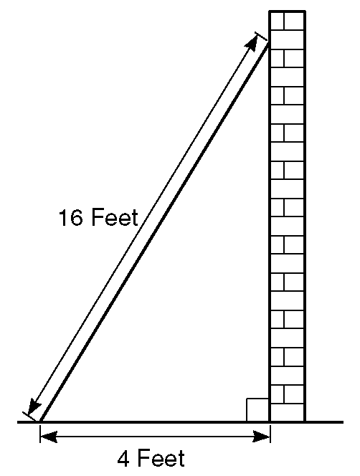

**(a)** Work out how high up the wall the ladder reaches.

Give your answer to 3 significant figures.

…………………………………………………………………………………………

…………………………………………………………………………………………

…………………………………………………………………………………………

…………………………………………………………………………………………

**(b)** Work out the angle the base of the ladder makes with the ground.

Give your answer to 3 significant figures.

***(Only attempt this if you are sitting the Higher Tier and have been taught trigonometry)***

…………………………………………………………………………………………

…………………………………………………………………………………………

…………………………………………………………………………………………

**(6 marks)**

|  |  |  |
| --- | --- | --- |
| **10 for 10** | **Year 11 mathematics: holiday revision**  **Non-Calculator** | **DAY 5** |

**9.** The diagram is a drawing of a triangular prism.



(a)Calculate the area of triangle *ABC*.

........................................................................................................................

........................................................................................................................

........................................................................................................................

(2)

(b)Calculate the volume of the prism.

........................................................................................................................

........................................................................................................................

........................................................................................................................

(2)

|  |  |  |
| --- | --- | --- |
| **10 for 10** | **Year 11 mathematics: holiday revision**  **Calculator** | **DAY 5** |

**10.** The diagram shows a cylinder.

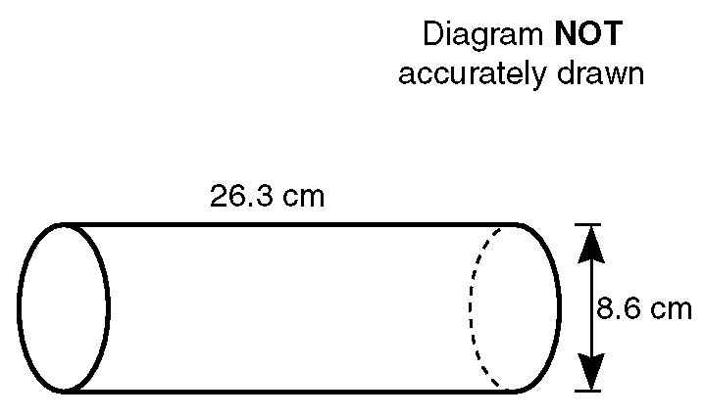

The height of the cylinder is 26.3 cm.

The diameter of the base of the cylinder is 8.6 cm.

Calculate the volume of the cylinder.

Give your answer correct to 3 significant figures.

........................................................................................................................

........................................................................................................................

........................................................................................................................

........................................................................................................................

........................................................................................................................

........................................................................................................................

(4 marks)

|  |  |  |
| --- | --- | --- |
| **10 for 10** | **Year 11 mathematics: holiday revision**  **Non-Calculator** | **DAY 6** |

**11.** (a) The triangle has angles *x*°, 2*x*° and 84° as shown.  
Find the value of *x*.



........................................................................................................................

........................................................................................................................

Answer .................................................... degrees

(3)

(b)5(2*x* – 1) = 35,

........................................................................................................................

........................................................................................................................

(2)

(c)4*x* + 3 = 18 – 2*x*.

........................................................................................................................

........................................................................................................................

(2)

|  |  |  |
| --- | --- | --- |
| **10 for 10** | **Year 11 mathematics: holiday revision**  **Calculator** | **DAY 6** |

**12.** The angles of a quadrilateral are 73°, 2*x*°, 3*x*° and 102°.



1. Write down an equation in *x*.

........................................................................................................................

........................................................................................................................

(2)

(b) Use your equation to find the largest angle in the quadrilateral.

........................................................................................................................

........................................................................................................................

Answer ............................................................ degrees

(3)

(c) Solve

 =  7.4

........................................................................................................................

........................................................................................................................

Answer *q* = .............................................................................................................

(2)

|  |  |  |
| --- | --- | --- |
| **10 for 10** | **Year 11 mathematics: holiday revision**  **Non-Calculator** | **DAY 7** |

**13.** (a) Simplify

10*d* + 3*e* – 2*d* – 7*e*

........................................................................................................................

........................................................................................................................

Answer ....................................................

(2)

(b) (i) Expand and simplify (2*x*  3)(3*x* + 5)

.............................................................................................................

.............................................................................................................

Answer ....................................................

(3)

(ii) Multiply out and simplify (*n* + 3)2

............................................................................................................

.

.............................................................................................................

Answer ....................................................

(3)

(c) Simplify

(i) *y*4  *y*-3

.............................................................................................................

Answer ....................................................

(1)

(ii) *y*4  *y*5

.............................................................................................................

Answer ....................................................

(1)

|  |  |  |
| --- | --- | --- |
| **10 for 10** | **Year 11 mathematics: holiday revision**  **Calculator** | **DAY 7** |

**14.** (a) Expand and simplify

*x*(2*x* – 3) + 4(*x*2 + 1)

........................................................................................................................

...............……………………………………………………………………

........................................................................................................................

........................................................................................................................

Answer ....................................................

(3)

(b) Factorise 4*c* + 64

...............……………………………………………………………………

Answer ....................................................

(1)

(c) Factorise *x*2 + 5*x*

...............……………………………………………………………………

...............……………………………………………………………………

Answer ....................................................

(2)

(d) Factorise 8*x*3*y*2 – 4*xy*3

...............……………………………………………………………………

...............……………………………………………………………………

Answer ....................................................

(2)

|  |  |  |
| --- | --- | --- |
| **10 for 10** | **Year 11 mathematics: holiday revision**  **Non-Calculator** | **DAY 8** |

**15.** James plants some sunflower seeds.  
He plants two seeds in each pot.

The probability that a seed grows is 

The probability tree diagram shows the outcomes for the two seeds in a pot.

(a) Complete the probability tree diagram.



(2)

(b) (i) What is the probability that both seeds grow?

.............................................................................................................

.............................................................................................................

(2)

(ii) What is the probability that at least one seed grows?

.............................................................................................................

.............................................................................................................

.............................................................................................................

(2)

|  |  |  |
| --- | --- | --- |
| **10 for 10** | **Year 11 mathematics: holiday revision**  **Calculator** | **DAY 8** |

**16(i).** Ruth made a spinner with three colours, green, blue and red.   
She tested it by spinning it 500 times.

 Her results were

227 landed on green  
176 landed on blue  
 97 landed on red.

(a) Estimate the probability of the spinner landing on blue.

........................................................................................................................

(2)

(b) In a game, the spinner is used 100 times.  
How many times would you expect the spinner to land on blue?

........................................................................................................................

(2)

**16(ii).** (a) Three cards are numbered 1, 3 and 4.Three discs are numbered 2, 4 and 5.

1

3

4

2

4

5

A game consists of picking one card at random and one disc at random. The numbers on the card and disc are added together.

Complete the table to show all the possible totals.

|  |  |  |  |  |
| --- | --- | --- | --- | --- |
|  |  | Disc | | |
|  |  | 2 | 4 | 5 |
| Card | 1 | 3 |  |  |
|  | 3 |  |  |  |
|  | 4 |  |  |  |

**(b)** What is the probability of getting a total which is an even number?.

**(4)**

|  |  |  |
| --- | --- | --- |
| **10 for 10** | **Year 11 mathematics: holiday revision**  **Non-Calculator** | **DAY 9** |

**17.** Write down the *n*th term for each of the following sequences.

(a) 3, 6, 9, 12 ....…..

.................................................................................................……………

.................................................................................................……………

(1)

(b) 1, 4, 7, 10 ....……

.................................................................................................……………

.................................................................................................……………

(1)

(c) 1, 4, 9, 16, ………

.................................................................................................……………

.................................................................................................……………

(1)

(d) 4, 16, 36, 64, ………

.................................................................................................……………

.................................................................................................……………

(2)

|  |  |  |
| --- | --- | --- |
| **10 for 10** | **Year 11 mathematics: holiday revision**  **Calculator** | **DAY 9** |

**18.** A sequence of numbers is shown below.

The first two terms are 3 and 4.

The remaining terms are found by adding together the two previous terms.

3, 4, 7, 11, 18, 29, . . .

(a) Write down the next two terms in the sequence.

........................................................................................................................

(1)

(b) The numbers from the first sequence are used to find the terms of a second sequence as shown below.

The terms are given to 2 decimal places.

4 ÷ 3 = 1.33

7 ÷ 4 = 1.75

11 ÷ 7 = 1.57

(i) Calculate the next three terms of this second sequence.

.......................................................................................................................

.

........................................................................................................................

........................................................................................................................

(ii) Write down what you notice about the terms in the second sequence.

.......................................................................................................................

........................................................................................................................

.

........................................................................................................................

(3)

|  |  |  |
| --- | --- | --- |
| **10 for 10** | **Year 11 mathematics: holiday revision**  **Non-Calculator** | **DAY 10** |

**19.** Ten pupils took two examination papers in Mathematics.

Their marks out of 50 were as follows.



(a) On the grid below draw a scatter diagram of these marks.



(2)

(b) Draw a line of best fit for the points you have plotted.

(1)

|  |  |  |
| --- | --- | --- |
| **10 for 10** | **Year 11 mathematics: holiday revision**  **Non-Calculator** | **DAY 10** |

(c) Omar was absent for Paper 2. He scored 32 marks on Paper 1.

(i) What mark do you think it fair to give him for Paper 2?

.............................................................................................................

(ii) State how you got your answer.

.............................................................................................................

.............................................................................................................

.............................................................................................................

(2)

(d) These pupils also took an examination paper in Art and one in Chemistry.  
A scatter diagram of these marks is drawn.  
How might it be different from the one drawn for the two Mathematics papers?

........................................................................................................................

........................................................................................................................

........................................................................................................................

(1)

|  |  |  |
| --- | --- | --- |
| **10 for 10** | **Year 11 mathematics: holiday revision**  **Calculator** | **DAY 10** |

**20.** The countries of the world are divided into ‘developed’ and ‘under-developed’ countries.

The frequency table shows the distribution of ages for the population in the developed countries.

The figures are percentages and were estimated for the year 1985.

|  |  |  |
| --- | --- | --- |
| Age (*y* years) | Percentage of  population | Cumulative Percentage |
| 0 < *y*  15 | 19 |  |
| 15 < *y*  30 | 22 |  |
| 30 < *y*  45 | 20 |  |
| 45 < *y*  60 | 17 |  |
| 60 < *y*  75 | 11 |  |
| 75 < *y*  90 | 9 |  |
| 90 < *y*  105 | 2 |  |

(a) Construct a cumulative frequency diagram to show this information.



(3)

|  |  |  |
| --- | --- | --- |
| **10 for 10** | **Year 11 mathematics: holiday revision**  **Calculator** | **DAY 10** |

(b) (i) What was the median age for the population in developed countries in 1985?

.............................................................................................................

**(1)**

(ii) The median age for the population in the under-developed countries in 1985 was 21.

What do the medians tell you about the difference between the population in the developed countries and the population in the underdeveloped countries?

.............................................................................................................

.............................................................................................................

.............................................................................................................

.............................................................................................................

(2)