**TGAU MATHEMATEG**

**Pecyn 10 am 10**

**Deg munud y dydd am ddeg dydd**



|  |  |
| --- | --- |
| **Yr Adran**  **Fathemateg** |  |

|  |  |  |
| --- | --- | --- |
| **10 am 10** | **Mathemateg Blwyddyn 11: adolygu dros y gwyliau**  **Di-gyfrifiannell** | **DYDD 1** |

**1.** Mewn cyngerdd ysgol un noson, roedd y gynulleidfa wedi’i chreu o’r canlynol:

$\frac{1}{4}$ yn ddynion, $\frac{3}{5}$ yn fenywod a’r gweddill yn blant.

(a) (i) Pa ganran o’r gynulleidfa sy’n blant?

.............................................................................................................

.............................................................................................................

(2)

(ii) Pa ffracsiwn o’r gynulleidfa sy’n blant?

.............................................................................................................

.............................................................................................................

.............................................................................................................

(3)

(b) Y noson ganlynol, mae’r gynulleidfa wedi’i chreu yn ôl y gymhareb ganlynol:

dynion : menywod : plant = 2 : 4 : 4

Mae 270 o bobl yn y gynulleidfa.  
Cyfrifwch nifer y dynion.

........................................................................................................................

........................................................................................................................

........................................................................................................................

(2)

|  |  |  |
| --- | --- | --- |
| **10 am 10** | **Mathemateg Blwyddyn 11: adolygu dros y gwyliau**  **Gyda Chyfrifiannell** | **DYDD 1** |

**2.** (a) Mae Miss Evans yn ennill £240 yr wythnos.  
Mae’n cael codiad cyflog o 3.5%.

Mae Mr Evans yn ennill £220 yr wythnos.  
Mae’n cael codiad cyflog o 4%.

Cyflog pwy sy’n cynyddu fwyaf?

**Rhaid** i chi ddangos eich holl waith cyfrifo.

.............................................................................................................

.............................................................................................................

.............................................................................................................

.............................................................................................................

.............................................................................................................

.............................................................................................................

Ateb ..................................................................

(4)

(b) Yn 2003 cynyddwyd y Pensiwn Gwladol gan 2% i £78.03.  
Beth oedd y Pensiwn Gwladol cyn y cynnydd hwn?

.............................................................................................................

.............................................................................................................

.............................................................................................................

Ateb £ .............................................................

(3)

|  |  |  |
| --- | --- | --- |
| **10 am 10** | **Mathemateg Blwyddyn 11: adolygu dros y gwyliau**  **Di-gyfrifiannell** | **DYDD 2** |

**3.** Yn y flwyddyn 1900, gwnaed amcangyfrifon ar gyfer nifer tri math gwahanol o forfilod. Gwnaed yr amcangyfrifon eto yn 1993.

Ni ddangosir y wybodaeth ar gyfer Morfilod Sei ar y diagram.

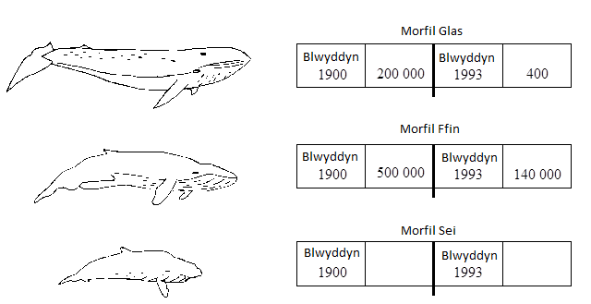

(a)Darganfyddwch y ffracsiwn canlynol, gan roi eich ateb ar ei ffurf symlaf.

Nifer y Morfil Ffin yn 1993

Nifer y Morfil Ffin yn 1900

........................................................................................................................

(1)

(b)Cyfrifwch y gostyngiad canrannol yn nifer y Morfilod Ffin rhwng blynyddoedd 1900 a 1993.

........................................................................................................................

........................................................................................................................

(3)

(c)Cymhareb Morfilod Sei 1900 i Forfild Sei 1993 yw 5: 1.

Cyfanswm y Morfilod ar gyfer y ddwy flwyddyn yma oedd 300,000.

Faint o Forfilod Sei a amcangyfrifwyd yn 1900?

........................................................................................................................

(2)

|  |  |  |
| --- | --- | --- |
| **10 am 10** | **Mathemateg Blwyddyn 11: adolygu dros y gwyliau**  **Gyda Chyfrifiannell** | **DYDD 2** |

**4.** Mae James yn buddsoddi £700 am 2 flwyddyn ar gyfradd adlog o 10% y flwyddyn. Faint o log y mae’n ennill?

..................................................................................................................................

..................................................................................................................................

..................................................................................................................................

..................................................................................................................................

Ateb £ ....................................................................

(2)

|  |  |  |
| --- | --- | --- |
| **10 am 10** | **Mathemateg Blwyddyn 11: adolygu dros y gwyliau**  **Di-gyfrifiannell** | **DYDD 3** |

**5.** Gwerthir iogwrt mewn potiau bach a photiau mawr.

(a) Mae pot bach yn costio 20c.  
Mae pot mawr yn costio 150% **yn fwy.**Faint ydy pot mawr yn ei gostio?

........................................................................................................................

........................................................................................................................

........................................................................................................................

........................................................................................................................

Ateb ........................................ ceiniog

(2)

(b) Cymhareb pwysau pot bach i bwysau pot mawr yw 3 : 11.  
Pwysau pot bach yw 120 g.

Beth yw pwysau pot mawr?

........................................................................................................................

........................................................................................................................

........................................................................................................................

........................................................................................................................

Ateb ................................................. g

(3)

(c) Mae pwysau’r pot bach wedi fesur yn gywir i’r gram agosaf.

Beth yw pwysau lleiaf posif y pot bach?

Ateb ................................................. g

(1)

|  |  |  |
| --- | --- | --- |
| **10 am 10** | **Mathemateg Blwyddyn 11: adolygu dros y gwyliau**  **Gyda Chyfrifiannell** | **DYDD 3** |

**6.** Cyfrifwch:



........................................................................................................................

........................................................................................................................

1. 24% o 35 metr.

........................................................................................................................

........................................................................................................................



1. ddegolyn:

........................................................................................................................

........................................................................................................................

1. canran:

........................................................................................................................

........................................................................................................................

(4)

|  |  |  |
| --- | --- | --- |
| **10 am 10** | **Mathemateg Blwyddyn 11: adolygu dros y gwyliau**  **Di-gyfrifiannell** | **DYDD 4** |

**7.**

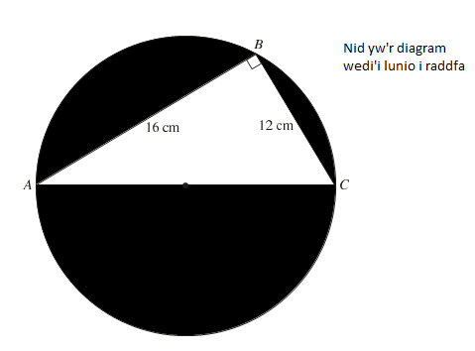

Mae’r diagram yn dangos triongl ongl sgwâr ABC a chylch.

Mae *A*, *B* a *C* yn bwyntiau ar gylchedd y cylch.

*AC* yw diamedr y cylch.

Darganfyddwch hyd AC..

…………………………………………………………………………………………

…………………………………………………………………………………………

…………………………………………………………………………………………

Gan gymryd bod  tua 3.14

Cyfrifwch arwynebedd rhan dywyll y cylch.

…………………………………………………………………………………………

…………………………………………………………………………………………

…………………………………………………………………………………………

…………………………………………………………………………………………

**(6)**

|  |  |  |
| --- | --- | --- |
| **10 am 10** | **Mathemateg Blwyddyn 11: adolygu dros y gwyliau**  **Gyda Chyfrifiannell** | **DYDD 4** |

**8.** Mae Sidney yn gosod gwaelod ei ysgol ar lawr llorweddol a’r brig yn erbyn wal fertigol.

Hyd yr ysgol yw 16 troedfedd.

Mae troed yr ysgol 4 troedfedd oddi wrth gwaelod y wal.

.

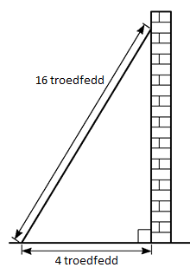

**(a)** Cyfrifwch pa mor uchel i fyny’r wal y mae’r ysgol yn cyrraedd.

Rhowch eich ateb yn gywir i 3 ffigur ystyrlon.

…………………………………………………………………………………………

…………………………………………………………………………………………

…………………………………………………………………………………………

…………………………………………………………………………………………

**(b)** Cyfrifwch yr ongl y mae gwaelod yr ysgol yn gwneud gyda’r llawr.

Rhowch eich ateb yn gywir i 3 ffigur ystyrlon.

***(Rhowch gynnig ar hyn dim ond os ydych yn sefyll y papur Haen Uwch.)***

…………………………………………………………………………………………

…………………………………………………………………………………………

…………………………………………………………………………………………

**(6)**

|  |  |  |
| --- | --- | --- |
| **10 am 10** | **Mathemateg Blwyddyn 11: adolygu dros y gwyliau**  **Di-gyfrifiannell** | **DYDD 5** |

**9.** Mae’r diagram yn dangos lluniad prism trionglog.



(a)Cyfrifwch arwynebedd triongl *ABC*.

........................................................................................................................

........................................................................................................................

........................................................................................................................

(2)

(b)Cyfrifwch gyfaint y prism.

........................................................................................................................

........................................................................................................................

........................................................................................................................

(2)

|  |  |  |
| --- | --- | --- |
| **10 am 10** | **Mathemateg Blwyddyn 11: adolygu dros y gwyliau**  **Gyda Chyfrifiannell** | **DYDD 5** |

**10.** Mae’r diagram yn dangos silindr.

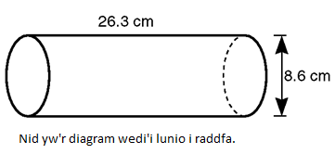

Uchder y silindr yw 26.3 cm.

Diamedr gwaelod y silindr yw 8.6 cm.

Cyfrifwch gyfaint y silindr.

Rhowch eich ateb yn gywir i 2 le degol.

........................................................................................................................

........................................................................................................................

........................................................................................................................

........................................................................................................................

........................................................................................................................

........................................................................................................................

(4)

|  |  |  |
| --- | --- | --- |
| **10 am 10** | **Mathemateg Blwyddyn 11: adolygu dros y gwyliau**  **Di-gyfrifiannell** | **DYDD 6** |

**11.** (a) Mae gan y triongl isod onglau *x*°, 2*x*° a 84° fel a ddangosir.  
Cyfrifwch werth *x*.

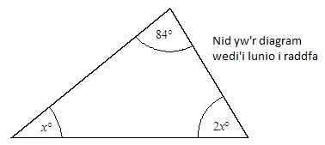

........................................................................................................................

........................................................................................................................

Ateb .................................................... gradd

(3)

(b)Datryswch5(2*x* – 1) = 35,

........................................................................................................................

........................................................................................................................

(2)

(c)Datryswch4*x* + 3 = 18 – 2*x*.

........................................................................................................................

........................................................................................................................

(2)

|  |  |  |
| --- | --- | --- |
| **10 am 10** | **Mathemateg Blwyddyn 11: adolygu dros y gwyliau**  **Gyda Chyfrifiannell** | **DYDD 6** |

**12.** Onglau pedrochr yw 73°, 2*x*°, 3*x*° a 102°.

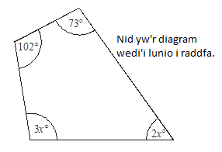

1. Ysgrifennwch hafaliad y mae *x* yn bodloni.

........................................................................................................................

........................................................................................................................

(2)

(b) Defnyddiwch eich hafaliad i ddarganfod maint ongl fwyaf y pedrochr.

........................................................................................................................

........................................................................................................................

Ateb ............................................................ gradd

(3)

(c) Datryswch

 =  7.4

........................................................................................................................

........................................................................................................................

(2)

|  |  |  |
| --- | --- | --- |
| **10 am 10** | **Mathemateg Blwyddyn 11: adolygu dros y gwyliau**  **Di-gyfrifiannell** | **DYDD 7** |

**13.** (a) Symleiddiwch

10*d* + 3*e* – 2*d* – 7*e*

........................................................................................................................

........................................................................................................................

(2)

(b) (i) Ehangwch a symleiddiwch (2*x*  3)(3*x* + 5)

.............................................................................................................

.............................................................................................................

(3)

(ii) Ehangwch a symleiddiwch (*n* + 3)2

............................................................................................................

.............................................................................................................

(3)

(c) Symleiddiwch

(i) *y*4  *y*-3

.............................................................................................................

(1)

(ii) *y*4  *y*5

.............................................................................................................

(1)

|  |  |  |
| --- | --- | --- |
| **10 am 10** | **Mathemateg Blwyddyn 11: adolygu dros y gwyliau**  **Gyda Chyfrifiannell** | **DYDD 7** |

**14.** (a) Ehangwch a symleiddiwch

*x*(2*x* – 3) + 4(*x*2 + 1)

........................................................................................................................

...............……………………………………………………………………

........................................................................................................................

........................................................................................................................

(3)

(b) Ffactoriwch 4*c* + 64

...............……………………………………………………………………

(1)

(c) Ffactoriwch *x*2 + 5*x*

...............……………………………………………………………………

...............……………………………………………………………………

(2)

(d) Ffactoriwch 8*x*3*y*2 – 4*xy*3

...............……………………………………………………………………

...............……………………………………………………………………

(2)

|  |  |  |
| --- | --- | --- |
| **10 am 10** | **Mathemateg Blwyddyn 11: adolygu dros y gwyliau**  **Di-gyfrifiannell** | **DYDD 8** |

**15.** Mae James yn plannu hadau cennin pedr.

Mae’n plannu dwy hedyn ym mhob pot.

Y tebygolrwydd y bydd hedyn yn tyfu yw 

Mae’r diagram cangen tebygolrwydd isod yn dangos y canlyniadau ar gyfer y ddau hedyn yn y pot.

(a) Cwblhewch y diagram cangen tebygolrwydd.

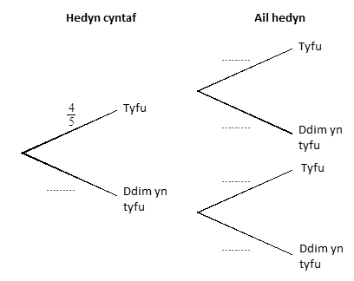

(2)

(b) (i) Beth yw’r tebygolrwydd y bydd y ddwy hedyn yn tyfu?

.............................................................................................................

.............................................................................................................

(2)

(ii) Beth yw’r tebygolrwydd y bydd o leiaf un hedyn yn tyfu?

.............................................................................................................

.............................................................................................................

.............................................................................................................

(2)

|  |  |  |
| --- | --- | --- |
| **10 am 10** | **Mathemateg Blwyddyn 11: adolygu dros y gwyliau**  **Gyda Chyfrifiannell** | **DYDD 8** |

**16(i).** Lluniodd Ruth droellwr gyda’r lliwiau coch, gwyrdd a glas arno.   
Cynhaliodd brawf arni gan ei droelli 500 gwaith.

 Dyma ei chanlyniadau

glanio 227 gwaith ar wyrdd

glanio 175 gwaith ar glas

glanio 98 gwaith ar goch.

(a) Amcangyfrifwch y tebygolrwydd y bydd y troellwr yn glanio ar las.

........................................................................................................................

(2)

(b) Mewn gêm, defnyddir y troellwr 100 o weithiau.  
Faint o weithiau y byddech yn disgwyl i’r troellwr lanio ar las?

........................................................................................................................

(2)

**16(ii).** (a) Mae tri cherdyn wedi’u rhifo 1, 3 a 4. Mae tri disg wedi’u rhifo 2, 4 a 5.

1

3

4

2

4

5

Mewn gêm mae angen dewis un cerdyn ac un disg ar hap. Mae’r rhifau ar y cerdyn a’r disg yn cael eu hadio.

Cwblhewch y tabl isod i ddangos yr holl bosibiliadau.

|  |  |  |  |  |
| --- | --- | --- | --- | --- |
|  |  | Disg | | |
|  |  | 2 | 4 | 5 |
| Cerdyn | 1 | 3 |  |  |
|  | 3 |  |  |  |
|  | 4 |  |  |  |

**(b)** Beth yw’r tebygolrwydd o gael cyfanswm sy’n eilrif?

........................................................................................................................

**(4)**

|  |  |  |
| --- | --- | --- |
| **10 am 10** | **Mathemateg Blwyddyn 11: adolygu dros y gwyliau**  **Di-gyfrifiannell** | **DYDD 9** |

**17.** Ysgrifennwch y rheol *n*fed term ar gyfer y dilyniannau canlynol.

(a) 3, 6, 9, 12 ....…..

.................................................................................................……………

.................................................................................................……………

(1)

(b) 1, 4, 7, 10 ....……

.................................................................................................……………

.................................................................................................……………

(1)

(c) 1, 4, 9, 16, ………

.................................................................................................……………

.................................................................................................……………

(1)

(d) 4, 16, 36, 64, ………

.................................................................................................……………

.................................................................................................……………

(2)

|  |  |  |
| --- | --- | --- |
| **10 am 10** | **Mathemateg Blwyddyn 11: adolygu dros y gwyliau**  **Gyda Chyfrifiannell** | **DYDD 9** |

**18.** Dangosirdilyniant o rifau isod.

Y ddau derm cyntaf yw 3 a 4.

Mae gweddill y termau yn cael eu cyfrifo trwy adio’r ddau rif blaenorol.

3, 4, 7, 11, 18, 29, . . .

(a) Ysgrifennwch ddau derm nesaf y dilyniant.

........................................................................................................................

(1)

(b) Defnyddir y rhifau o’r dilyniant cyntaf i greu termau ail ddilyniant, fel a ddangosir isod.

Rhoddir y termau i 2 le degol.

4 ÷ 3 = 1.33

7 ÷ 4 = 1.75

11 ÷ 7 = 1.57

(i) Cyfrifwch dri therm nesaf yr ail ddilyniant hwn.

.......................................................................................................................

........................................................................................................................

........................................................................................................................

(ii) Ysgrifennwch yr hyn a sylwch am y termau yn yr ail ddilyniant.

.......................................................................................................................

........................................................................................................................

.

........................................................................................................................

(3)

|  |  |  |
| --- | --- | --- |
| **10 am 10** | **Mathemateg Blwyddyn 11: adolygu dros y gwyliau**  **Di-gyfrifiannell** | **DYDD 10** |

**19.** Safodddeg ddisgybl ddau bapur arholiad mewn Mathemateg.

Nodir eu marciau, allan o 50, isod.

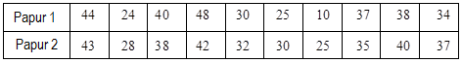

(a) Ar y grid isod, lluniwch ddiagram gwasgariad o’r marciau hyn.

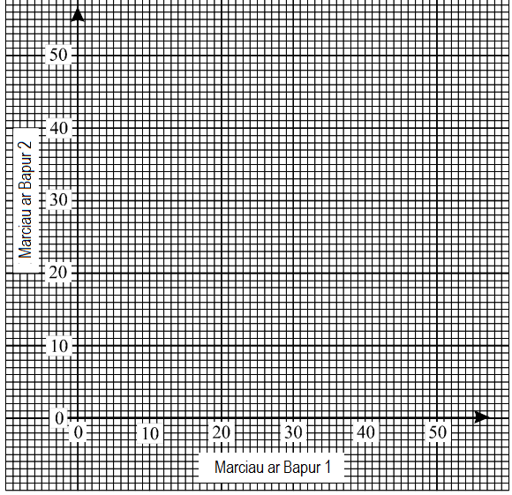

(2)

(b) Lluniwch linell ffit orau ar gyfer y data hwn.

(1)

|  |  |  |
| --- | --- | --- |
| **10 am 10** | **Mathemateg Blwyddyn 11: adolygu dros y gwyliau**  **Di-gyfrifiannell** | **DYDD 10** |

(c) Roedd Omar yn absennol ar gyfer Papur 2. Cafodd farc o 32 ar Bapur 1.

(i) Pa farc y credwch y byddai wedi’i ennill ar Bapur 2?

.............................................................................................................

(ii) Nodwch sut y cawsoch eich ateb.

.............................................................................................................

.............................................................................................................

.............................................................................................................

(2)

(ch) Safodd y disgyblion hyn bapur arholiad hefyd mewn Celf ac un arall mewn Cemeg.  
Llunir diagram gwasgariad ar gyfer y marciau hyn.  
Sut gall y diagram gwasgariad hwn fod yn wahanol i’r un a luniwyd ar gyfer y papurau Mathemateg?

........................................................................................................................

........................................................................................................................

........................................................................................................................

(1)

|  |  |  |
| --- | --- | --- |
| **10 am 10** | **Mathemateg Blwyddyn 11: adolygu dros y gwyliau**  **Gyda Chyfrifiannell** | **DYDD 10** |

**20.** Dosberthirgwledydd y bydd i grwpiau ‘datblygedig’ a ‘llai datblygedig’.

Mae’r tabl amlder isod yn dangos dosraniad oedrannau’r boblogaeth ar gyfer y gwledydd datblygedig.

Mae’r ffigurau mewn canrannau, ac yn amgyfrifon ar gyfer y flwyddyn 1985.

|  |  |  |
| --- | --- | --- |
| Oedran (*y* blwydd) | Canran y boblogaeth | Canran cronnus |
| 0 < *y*  15 | 19 |  |
| 15 < *y*  30 | 22 |  |
| 30 < *y*  45 | 20 |  |
| 45 < *y*  60 | 17 |  |
| 60 < *y*  75 | 11 |  |
| 75 < *y*  90 | 9 |  |
| 90 < *y*  105 | 2 |  |

(a) Lluniwch bolygon amlder cronnus i ddangos y wybodaeth hon.

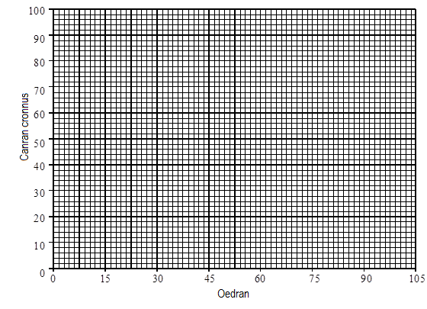

(3)

|  |  |  |
| --- | --- | --- |
| **10 am 10** | **Mathemateg Blwyddyn 11: adolygu dros y gwyliau**  **Gyda Chyfrifiannell** | **DYDD 10** |

(b) (i) Beth oedd yr oedran canolrifol ar gyfer gwledydd datblygedig yn 1985?

.............................................................................................................

**(1)**

(ii) Yr oedran canolrifol ar gyfer y boblogaeth mewn gwledydd llai datblygedig yn 1985 oedd 21.

Beth ydy’r ddau oedran canolrifol yn dweud wrthych am y gwahaniaeth rhwng y boblogaeth yn y gwledydd datblygedig a’r boblogaeth yn y gwledydd llai datblygedig?

.............................................................................................................

.............................................................................................................

.............................................................................................................

.............................................................................................................

(2)

|  |  |
| --- | --- |
| Answers | Online Revision Resources |
| DYDD 1:  Day 1 | **Fraction**  <http://studymaths.co.uk/workout.php?workoutID=11>  **Percentage – convert fraction, decimal, percentage**  Notes  <http://studymaths.co.uk/keytopics/fractionsdecimalspercentages.html>  Worksheet  <http://studymaths.co.uk/workout.php?workoutID=80>  **Ratio**  <http://studymaths.co.uk/workout.php?workoutID=116>  **Percentage of an amount**  <http://studymaths.co.uk/workout.php?workoutID=38>  **Find the original after a percentage change**  Notes  <http://studymaths.co.uk/keytopics/percentagechange.html>  Worksheet  <http://studymaths.co.uk/workout.php?workoutID=78> |
| DYDD 2:  Day 1 | **Percentage decrease**  <http://studymaths.co.uk/workout.php?workoutID=84>  **Ratio**  <http://studymaths.co.uk/workout.php?workoutID=75>  **Percentage increase**  <http://studymaths.co.uk/workout.php?workoutID=39>  **Compound interest**  Notes  <http://studymaths.co.uk/topics/simpleAndCompoundInterest.php>  **Sharing amounts in a given ratio**  Notes  <http://studymaths.co.uk/keytopics/ratio.html> |
| DYDD 3:  Day 3 | **Percentage increase** (same as DYDD 2)  <http://studymaths.co.uk/workout.php?workoutID=39>  **Ratio of an amount**  <http://studymaths.co.uk/workout.php?workoutID=116>  **Rounding** (minimum value)  Decimal places  <http://studymaths.co.uk/workout.php?workoutID=61>  Significant figures  <http://studymaths.co.uk/workout.php?workoutID=62>  **Fraction of an amount**  Notes  <http://studymaths.co.uk/keytopics/fractionsofamounts.html>  Worksheet  <http://studymaths.co.uk/workout.php?workoutID=22>  **Percentage of an amount**  <http://studymaths.co.uk/workout.php?workoutID=38> |
| DYDD 4:  Day 4 | **Pythagoras’ Theorem**  Notes  <http://studymaths.co.uk/keytopics/pythagoras.html>  Worksheet  <http://studymaths.co.uk/workout.php?workoutID=16>  **Area of a circle**  Notes  <http://studymaths.co.uk/keytopics/circles.html>  Worksheets  <http://studymaths.co.uk/workout.php?workoutID=45> |
| DYDD 5:  Day 5 | **Area of a triangle**  <http://studymaths.co.uk/workout.php?workoutID=66>  **Volume of a prism**  Notes  <http://studymaths.co.uk/keytopics/volumeofprisms.html>  **Volume of a cylinder**  <http://studymaths.co.uk/workout.php?workoutID=69> |
| DYDD 6:  Day 6 | |  | | --- | | **Solving equations**  Notes  <http://studymaths.co.uk/keytopics/equations.html>  Worksheets  [Solving equations with brackets](http://studymaths.co.uk/workout.php?workoutID=15) | | [Solving equations with brackets and unknowns on both sides](http://studymaths.co.uk/workout.php?workoutID=127) | | [Solving equations with unknowns on both sides](http://studymaths.co.uk/workout.php?workoutID=31) | | [Solving one-step equations](http://studymaths.co.uk/workout.php?workoutID=13) | | [Solving two-step equations](http://studymaths.co.uk/workout.php?workoutID=14) | |
| DYDD 7:  Day 7 | **Simplify**  <http://studymaths.co.uk/workout.php?workoutID=126>  **Expand**  [Expanding single brackets](http://studymaths.co.uk/workout.php?workoutID=71)  [Expanding and simplifying brackets](http://studymaths.co.uk/workout.php?workoutID=121)  [Expanding quadratic expressions](http://studymaths.co.uk/workout.php?workoutID=44)  **Factorise**  [Factorising linear expressions](http://studymaths.co.uk/workout.php?workoutID=72)  **Laws of indices**  [Laws of indices](http://studymaths.co.uk/workout.php?workoutID=77) |
| DYDD 8:  Day 8 | **Probability**  [Theoretical probability](http://studymaths.co.uk/workout.php?workoutID=132)  **Estimated probability**  [Expected frequency](http://studymaths.co.uk/workout.php?workoutID=55) |
| DYDD 9:  Day 9 | **Sequences**  Notes  <http://studymaths.co.uk/keytopics/nthterm.html>  Worksheets  [Finding the next term of a sequence](http://studymaths.co.uk/workout.php?workoutID=112)  [Finding the nth term rule](http://studymaths.co.uk/workout.php?workoutID=20)  [Generating terms using the nth term rule](http://studymaths.co.uk/workout.php?workoutID=32) |
| DYDD 10:  Day 10 | **Scatter diagrams**  **Cumulative frequency** |